
Dashboard Design

Date | 28/10/2026
Team ID | Suhani jain
Project Name | Electric Vehicle Market Performance & Insights
Maximum Marks | 5 Marks

An effective dashboard presents important information clearly and helps the intended audience explore market performance. For this project, the dashboard combines EV sales, manufacturer competition, battery technology, driving range, manufacturing locations, and customer ratings into one interactive view.
Activity 1: Interactive and Visually Appealing Dashboard
The dashboard should use a clear layout, suitable visualizations, consistent colours, and interactive filters. Users should be able to compare categories and manufacturers, investigate trends, and identify areas for improvement. Recommended design practices:
- Clear and Intuitive Layout: Place key performance indicators at the top, followed by comparison charts.
- Appropriate Visualizations: Use bar charts for category sales and manufacturer rankings, a pie/donut chart for battery mix, and a line chart for yearly sales trends.
- Consistent Colour Theme: Use a small, consistent palette and keep colours for categories or battery types consistent across charts.
- Interactive Filters and Slicers: Add filters for year, manufacturer, vehicle category, country, and battery technology.
- Drill-Down Capabilities: Allow users to move from overall market figures to a selected manufacturer, category, or country.
- Responsive Design: Ensure chart titles, legends, labels, and KPI cards remain readable.
- Useful Tooltips and Labels: Show values, units, time period, and definitions when users hover over charts.
- Dashboard Navigation: Use clear section headings or navigation buttons for Overview, Battery Analysis, and Customer Ratings.
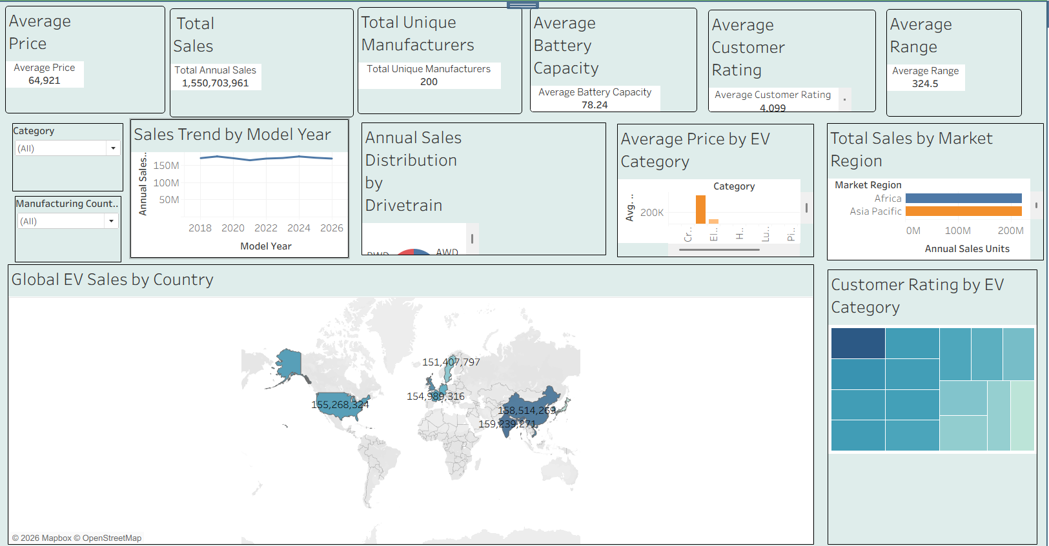
Outcomes-
- Stagnant or Plateaued Sales Growth: The "Sales Trend by Model Year" line chart shows a flat line across recent years, indicating that annual sales volume has leveled off rather than continuing a rapid upward growth trajectory.
- Highly Imbalance in Category Pricing: The "Average Price by EV Category" chart reveals a dramatic spike for one specific category compared to all others, indicating that a particular segment command an exceptionally high premium in the market.
- Geographic Concentration of Sales: The "Total Sales by Market Region" and "Global EV Sales by Country" charts highlight that the vast majority of sales unit volume is concentrated in a specific region (such as Asia Pacific) and a select few countries, rather than being evenly spread globally.
- High Brand Fragmentation: With the "Total Unique Manufacturers" KPI card reading 200, the market is highly fragmented with a vast number of competing brands, which likely intensifies competition and offers customers extensive variety.
- Positive Overall Customer Sentiment: The "Average Customer Rating" KPI stands solidly at 4.099, showing that despite varying categories and price points, consumer satisfaction and sentiment toward EV performance remain highly positive on average.

Activity 2
Publish Dashboard on Tableau Public and Paste the Dashboard Public link below:
https://public.tableau.com/shared/T5BRTWSYG?:display_count=n&:origin=viz_share_link

